Gold Sluice design
http://www.youtube.com/watch?v=MkVVNzBB0RM

Do It Yourself, Homemade Gold Sluice Box

http://nevada-outback-gems.com/design_plans/DIY_hand_sluice/hand_sluice.htm
Locations for Gold Prospecting
http://nevada-outback-gems.com/prospecting_info/Nugget_detect_possib.htm
http://www.youtube.com/watch?v=T9tF-QP2BTg&feature=endscreen&NR=1
http://www.youtube.com/watch?v=HALbg1-tR7k&NR=1&feature=fvwp
Large Gold Sluice Plans
Small Portable Sluice
The most common size of portable gold sluices seems to be three feet in length and one foot in
width. This is the best compromise in fine gold recovery and reasonable portability. This sluice
will handle an increase in water flow due to taller 8 inch side rails and in turn an increase in the
rate of processing of gold-bearing material.
This sluice is based on the idea of being simple in design and methods of construction. No cutting
torch or arc welder involved; only hand tools or lightweight power tools. Since all of the
wood cuts are cross cuts, the only large power tool I used is a radial arm saw. If you don't have a
radial arm saw a hand saw, circular saw or router can be used to make the cuts and riffles.
For cutting carpet and ribbed matting, a sharp utility knife or heavy duty scissors works well.
Galvanized nails or deck screws can be used to assembly the pieces together but, since the wood
is relatively thin, predrill all holes to reduce splitting. A cordless drill with a quick-change bit
system is a real time saver on this type of project.
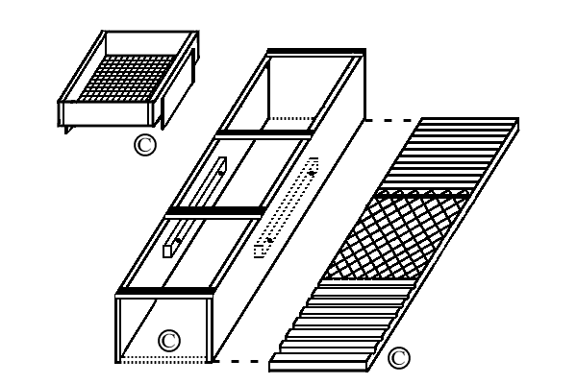

The first foot of sluice is ribbed rubber matting, the second foot is expanded metal grate on top
of carpet or miner's moss and the third foot is riffles cut into the wood. A variation on the riffles
is to use wood or plastic quarter-round trim available at any home improvement store.
The expanded metal grate acts as a method to hold the carpet in place and the grate is held in
place by foot long clamps along the bottom of the side rails. The clamps are held in place by
machine screws that protrude through the clamps and side rails and are secured on the outside
of the side rails with wing nuts. This setup provides for easy disassembly and removal of the carpet
during cleanup. The clamps can be made of wood, pvc or metal.
Also shown is a screen that fits between the first two braces and on top of the side rails.
This allows the prospector to shovel directly into the sluice and prescreen the gravel in one step.
Prescreening helps in the recovery of gold by eliminating large rocks that could tear up the
sluice and dislodge any gold already recovered. The screen is easily removed and dumped when
full. Have a great time and find gold!

Large Gold Sluice
How to build a gold sluice using basic hand tools and/or lightweight power tools.
A quick, easy project that costs next to nothing to build and increases the recovery rate
of gold. Length is a matter of preference. A longer sluice recovers more gold but a shorter
one is more portable. On larger sluices, the side rails should be made taller to handle more
water flow and more material. Each riffle is comprised of several saw kerfs placed closely
together. The total number of riffles is left up to the maker. The last riffle is the largest and
serves as a nugget trap. Predrill all nail holes to prevent wood from splitting. Use of screws
would allow disassembly for ease of transport and storage. After assembly, use caulk to seal
any gaps. Ribbed matting is simply attached at the leading edge.
Carrying handle (1x2 cut to length) can be placed anywhere between or on top of the side
rails. Add paint to waterproof (pieces should be painted before assembly) or use as-is.
Wear eye protection when using any tools. Have fun and find gold!
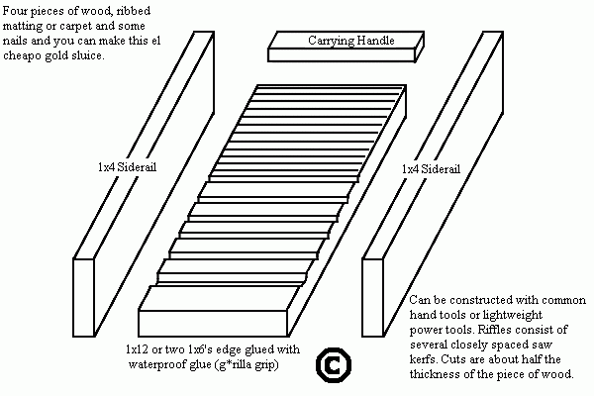

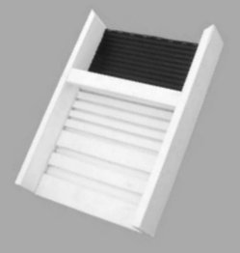
Completed sluice. Total length is about 18 inches.
A sluice this size is easy to carry to remote areas and over difficult terrain. The gold bearing
material should be pre-screened and fed at a low rate. That way the gold has a better chance
to settle out in the relatively short distance it travels through this sluice. The sluice needs to
be adjusted at a slight downward angle to allow the water flow to separate the materials.
The lightweight blond sand should be washing away while the heavier black sand and gold
are trapped in the riffles. If the riffles fill up quickly with lightweight material, the angle or
the flow of water needs to be increased. A large rock positioned on top of the sluice will keep
it from being swept downstream.

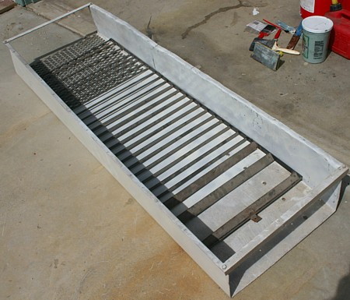
How I built a recirculating sluice box for gold prospecting
It was easy. You can do it too
http://www.mdpub.com/sluice/index.html
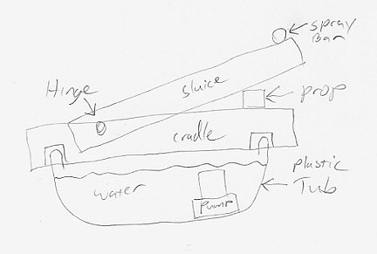
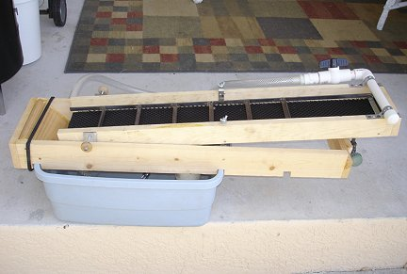
http://www.blackcatmining.com/mining-equipment/sluice-box.cfm
http://www.blackcatmining.com/mining-equipment/kit.cfm
http://www.goldsluice.net/
http://goldminingclaimsecrets.com/report.html
http://www.keeneeng.com/Merchant2/merchant.mvc?Screen=CTGY&Category_Code=GS
Find Gold Nuggets Underwater
There was a newspaper story recently about an old prospector in California
who recovered a small fortune in gold with the simple tools shown here.
The first, is simply a PVC tube with clear plastic glued onto one or both ends.
It allows looking through cloudy, running water to find gold in the cracks
and crevasses of gold bearing streams. A handle is necessary to help
control the buoyancy of the hollow tube and to keep it steady underwater.
The methods of attaching the handle can vary: sheet metal screws, zip ties,
radiator hose clamps, epoxy, silicone glue-seal.
To help counteract the buoyancy problem, the top of the tube could be left
open and the tube filled with clear water from a calm area of the stream.
The water in the tube would also give a magnifying effect.
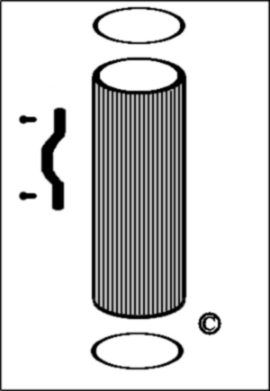
PVC Tube
The PVC should be no less than four inches in diameter so both eyes can
be used to look through the tube. The length doesn't matter too much but
a longer tube gives a more pronounced "tunnel vision" effect and is more
awkward to carry. An eighteen to twenty-four inch tube is a good
all-around size.
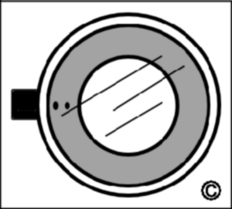
Top View
The other parts of this nugget finder are the tools for cleaning out the cracks
to find the gold trapped within. A long handled "cook's spoon" or a garden
trowel will work nicely. A piece of wire coat hanger or uncoated brass
welding rod with a few bends added helps in cleaning out tiny areas.
Another handy item is a screwdriver for cleaning out the narrower crevices
and for prying nuggets loose. A pry bar is always useful for opening up
cracks and crevices and loosening rocks to search for nuggets trapped
underneath. A turkey baster can be useful for providing a puff of air or a
stream of water to clean out crevices above the waterline. A metal
detector is a real time saver to locate the nuggets without doing a lot of
extra digging then a person can use these other tools to recover them.
Metal detectors made for locating the smallest nuggets are rather expensive,
but finding a few real nice nuggets could make the cost worthwhile.
See Metal Detectors page.
Gold Dredge For One
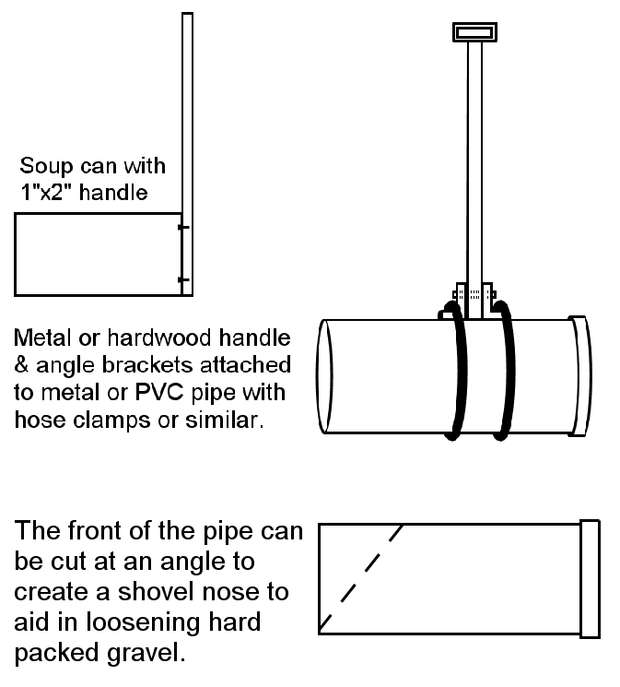
Portable gold dredge tool for digging around and behind large rocks in stream beds.
This tool traps the material better than a shovel and can be used with a shovel to scoop
up gold bearing gravel like using a broom and dustpan.
Hose clamps can be used to attach the handle or bolts can be placed through the angle
brackets into the pipe.
Tool can be broken down for easy transport and assembled on site with a pocket toolkit.
Soup or juice can model is very light duty but is handy for cleaning out crevices.

